SCBC Factory Tool Instruction for online mode

Install
Turn on setup application
Example:

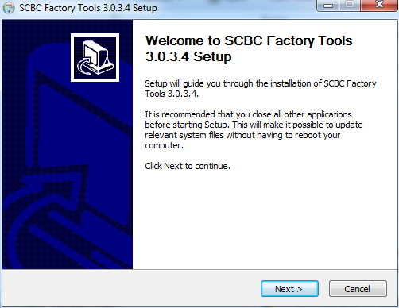
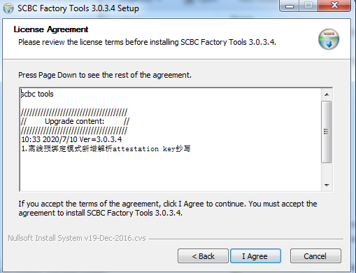

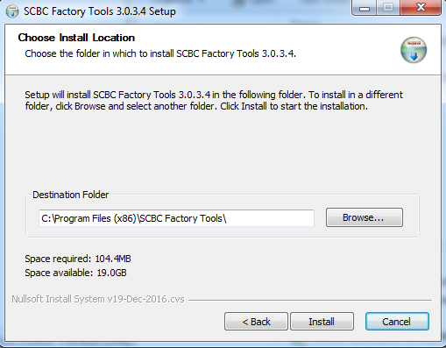
Runtime install
If it’s your first time installing and PC missing .Net4.5 runtime, software will install .Net4.5 first.
It will take a few minutes.

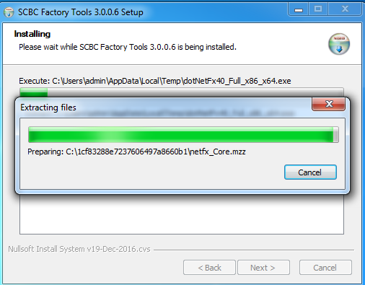
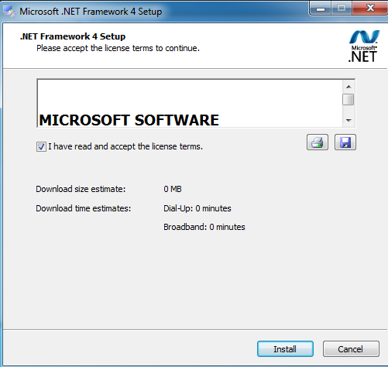
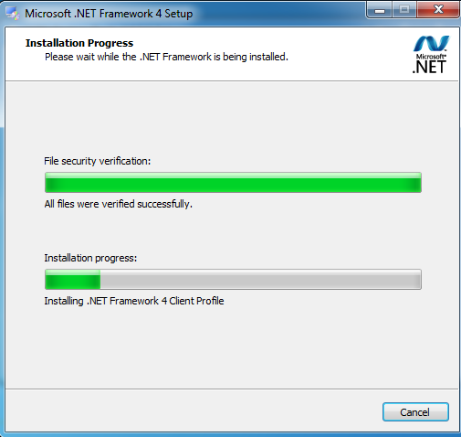
After install, it will create a shortcut on the desktop
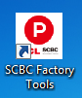

Login
If use online mode, you must input the correct account and password to enter the operate page.
The account and password will be provided after permission confirmed. (See 5.2)
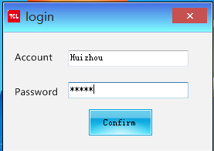

After login:
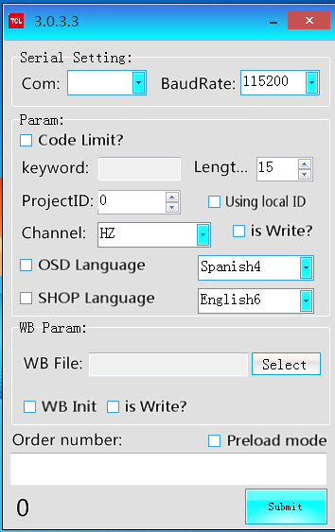

Config
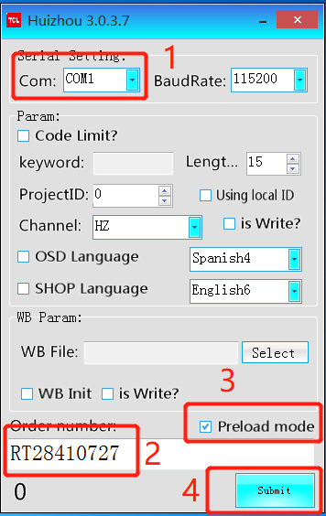

Select the Com port of TV

Input the order name

Click preload mode

Click submit button

If it’s your first time submit the order, the tool will start the download process of the key DB file.
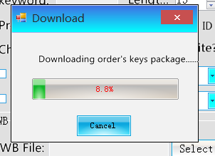
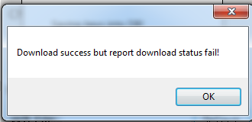
Ignore this message and click ok.

Then click the submit again
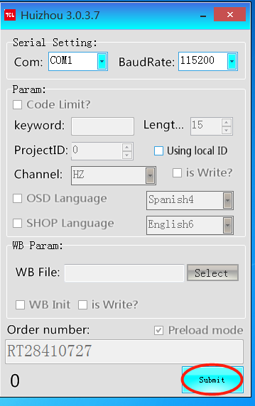

And you can see the operate page and some basic message of the order:

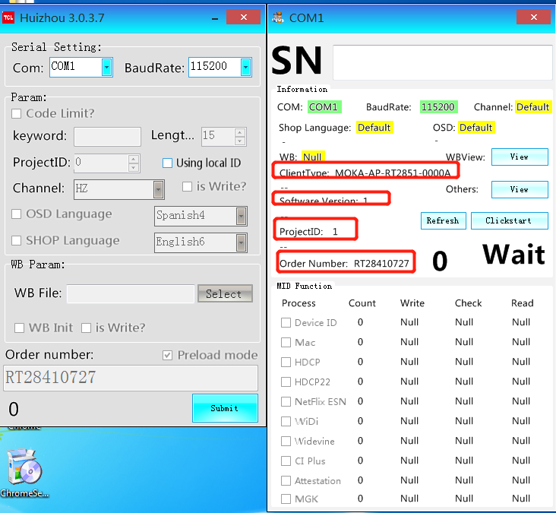

Testing
Focus on the testbox of SN, and scan the barcode of PCB, then it will trigger the testing.
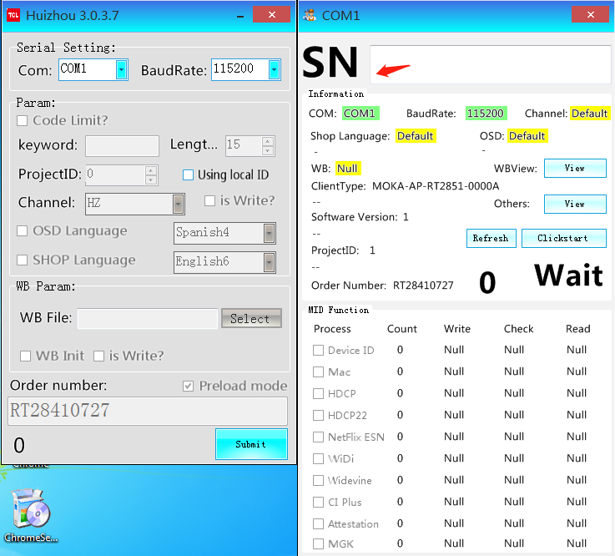
And you will see the burning key selected automatic.
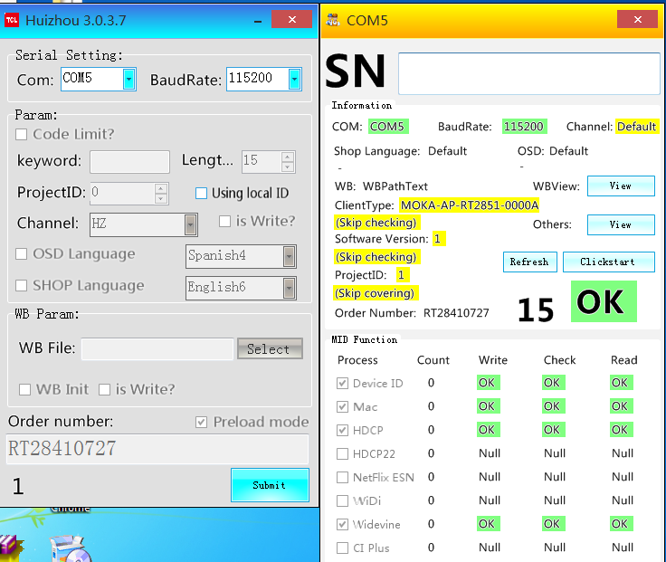

Special note

Network preparation
Make sure the PC used for production connecting Internet.
Enter the following website, if it working, means the network is ok:
https://cn.uc.qhmoka.com/scbc-server
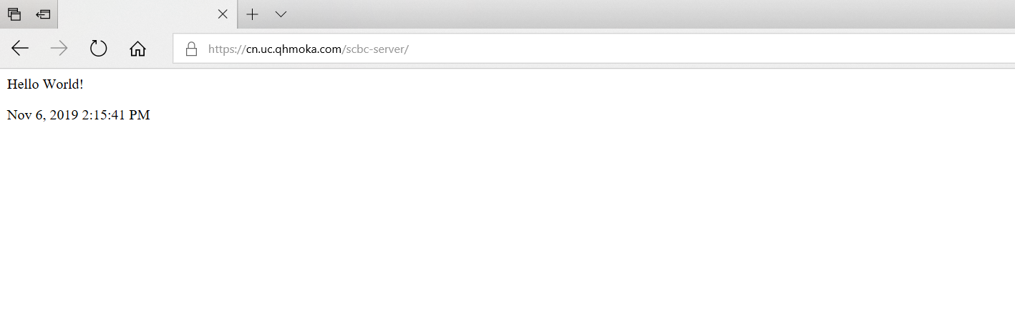

Add permission for PC
Provide the Mac addresses of PC to us; we will add the permission for each user side.

Example:
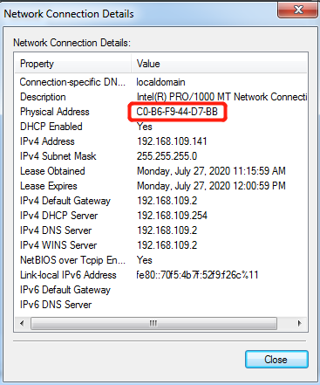

6.3 Factory must provide the SN list of order before production, MID server system will distribute the keys depend on SN list and create the DB file. Then the factory tool will parse the DB file and burn the key into mainboard according to SN input from scanner.

